FPGA Snake Game
ECE 3300 - Digital Logic Design
Final Project Report
Yousef Sanobara | Brendan Dial

1. System Description
We built a fully playable Snake game on the Nexys A7-100T FPGA board. The game runs in real time on a 20x15 grid, displayed at 640x480 over VGA. The snake moves one cell per game tick at a speed set by the onboard switches. Food items spawn at random positions generated by a 16-bit LFSR, and the snake grows each time it eats one. The game ends when the snake collides with itself, or with a wall if the wall-deadly mode is turned on.

The design is organized into a hierarchy of modules: a top-level structural wrapper, a game logic module containing the FSM and FIFO, a VGA renderer, a UART transmitter, a 7-segment display driver, and supporting utility modules for debouncing, edge detection, and random number generation.

The player controls the snake using the four directional buttons. The switches configure game behavior including apple count, snake color, speed, and wall mode. Score is shown on the 7-segment display and is also sent over UART to a connected PC terminal whenever it changes.

2. Required I/O
Buttons
Button | Function
BTNC | Global reset: returns the system to IDLE state
BTNU | Move snake up
BTND | Move snake down
BTNL | Move snake left
BTNR | Move snake right

Switches
Switch | Function
SW0 | Toggle score bar overlay on VGA screen
SW1 | Start / Pause / Resume: every flip of the switch triggers a state change
SW2 | Set apple count to 1
SW3 | Set apple count to 2 (overrides SW2)
SW4 | Set apple count to 3 (overrides SW2-3). All off = 0 apples (survival mode)
SW5 | Wall mode = OFF: wrap around, ON: walls are deadly
SW6 | Snake color: Blue
SW7 | Snake color: Green
SW8 | Snake color: Red
SW9 | Snake color: Yellow
SW10 | Rainbow mode: each body segment cycles through all five colors
SW11-15 | Speed levels 1 through 5. Higher switch = faster snake

Multiple color switches on at the same time cycle through only those selected colors along the snake body , SW6 and SW8 together gives a blue-red-blue-red pattern, for example.

LEDs
LEDs | What is Shown
LED[15:12] | Game state one-hot: 0001=IDLE, 0010=PLAYING, 0100=PAUSED, 1000=GAME OVER
LED[11:8] | Active speed level, mirrors SW[15:12]
LED[7:0] | Snake length progress bar, fills as the snake grows

7-Segment Display
Digits | What is Shown
Left 4 digits | Current score in hexadecimal
Right 4 digits | High score (SW4 off) or current snake length (SW4 on)

UART
The UART transmitter runs at 9600 baud (8N1) over the Nexys A7 USB-UART bridge. Two events trigger a transmission: when the snake eats food, the current score byte is sent; when a collision ends the game, 0xFF is sent as a game-over signal. A connected PC terminal shows these events in real time.

VGA
The output runs at 640x480, 60Hz. Each of the 300 grid cells is rendered as a 32x32 pixel block. The display changes based on game state:

State | Display
IDLE | Blinking blue checkerboard = waiting for SW1
PLAYING | Game grid with snake, food items, and optional score bar (SW0)
PAUSED | Game grid frozen, background dimmed
GAME OVER | Red flashing screen = collision occurred

3. FSM: Finite State Machine

The game state machine has four states and lives inside snake_game.v. Every transition is driven by either a switch edge or a game tick collision event.

State | Description
IDLE | Waiting to start. The LFSR and tick counter are held in reset. Snake and food are inactive.
PLAYING | Game is running. On each tick the snake moves, collisions are checked, food is consumed if the head overlaps a food cell, and score increments if food was eaten.
PAUSED | Tick counter is frozen. The VGA still renders the current grid but nothing moves.
GAME OVER | Entered when wall or self collision is detected on a tick. UART fires to send 0xFF. Display flashes red until the player restarts.

Transition | Trigger
IDLE → PLAYING | SW1 edge
PLAYING → PAUSED | SW1 edge
PAUSED → PLAYING | SW1 edge
PLAYING → GAME OVER | wall_hit or self_hit on a game tick
GAME OVER → IDLE | SW1 edge

SW1 fires on both rising and falling edges so every flip of the switch triggers a transition, regardless of direction.

4. FIFO: Snake Body Storage
The snake body is stored in snake_fifo.v, a shift-register FIFO with a maximum depth of 300 entries matching the total grid size. Each entry holds a 9-bit grid position in the format {x[4:0], y[3:0]}. Index 0 is always the head and index len-1 is the tail.

Mode | Behavior
push=1, grow=0 | Normal movement. All entries shift, new head pushed to index 0, length unchanged. The tail falls off.
push=1, grow=1 | Food eaten. All entries shift, new head pushed, length incremented. Tail is preserved.

The full memory is packed into a flat output bus (body_flat) connected to both the renderer and the self-collision checker. The renderer uses a for-generate loop to build 300 parallel comparators that check each body segment against the current pixel cell. The collision checker uses a similar loop to detect whether the new head position already exists in the active snake.

At the start of each game, the FIFO length resets to zero and three initial segments are pushed in to place the snake at the center of the grid facing right.

5. Verilog Modeling Styles
Style | Where and How It Is Used
Gate-level | lfsr16.v: the LFSR feedback is built from three chained xor gate primitives (g0, g1, g2) to directly model the XOR tap network.
Structural | top.v: every submodule is instantiated by name with explicit port connections. No logic is written directly in top.v itself.
Behavioral | snake_game.v: FSM state transitions, FIFO control, direction latch, and food spawning are written as always @(posedge clk) blocks.
Dataflow | vga_sync.v and renderer.v: all output signals driven by assign statements covering sync timing, pixel address calculation, and hit detection.

The design also uses for-generate loops, parameters, localparams, and `define macros for grid dimensions and color constants.

6. Testbench Strategy
The master testbench tb_top.v instantiates the full top-level module with SIM=1, which shortens game ticks from millions of cycles to 100 cycles so the full scenario runs in a reasonable simulation time.

Five reusable tasks handle all stimulus:

Task | What It Does
press_btn | Holds a button for 50 cycles then releases. Debounce is N=3 in simulation mode so the 50-cycle press registers correctly.
toggle_sw | Flips a switch bit with a #1ns delay after the clock edge to avoid delta-cycle race conditions with the edge detectors.
wait_ticks | Waits for N game ticks using a for loop (110 cycles per tick with margin).
check_state | Reads internal game_state and prints PASS or FAIL to the Tcl console.
check_score | Reads internal score and prints PASS or FAIL.

The test sequence covers the full game lifecycle:

- Reset via BTNC, verify IDLE
- Start game via SW1, verify PLAYING, confirm score is zero
- Cycle through all four directions with a for loop
- Pause and resume via SW1, verify state changes
- Enable deadly walls, crash snake into wall with repeated BTNU presses
- Verify GAME OVER, restart, confirm score resets to zero

7. Simulation Results
The waveform below was captured from the behavioral simulation in Vivado. The testbench was run with SIM=1 to compress game ticks down to 100 clock cycles, allowing the full scenario to complete in a short simulation window.

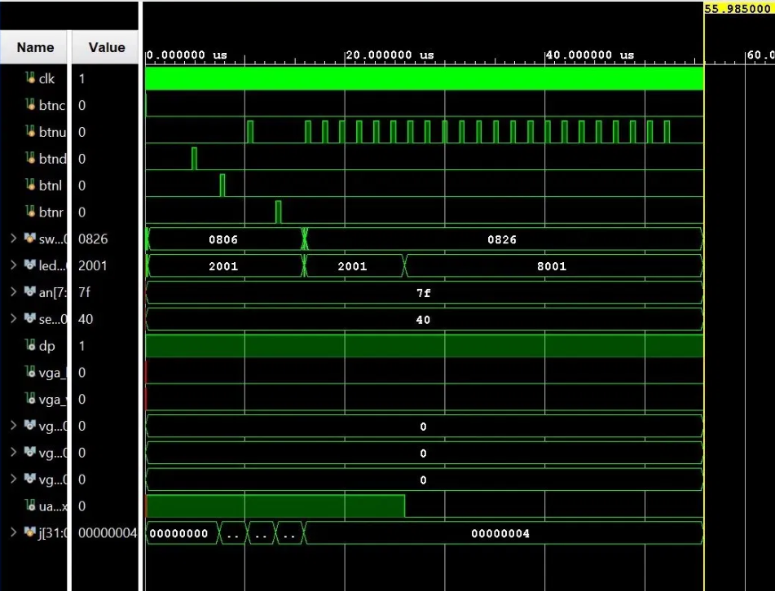
The led signal starts at 2001 (hex), which corresponds to game_state = PLAYING with one snake length bar bit set. It holds that value through the direction test and pause/resume sequence, then transitions to 8001 when the snake crashes into the wall with SW5 enabled. The 8001 value confirms game_state = GAME OVER.

The sw signal starts at 0806 (SW1, SW2, and SW11 active) and transitions to 0826 when SW5 is turned on to enable deadly walls for the crash test. The btnd, btnl, and btnr signals each show a single pulse from the direction test loop, and btnu shows a burst of pulses from the 22 repeated up-presses used to steer the snake into the top wall.

The uart_txd line goes low for a period after the crash, which is the UART transmitter sending the 0xFF game-over byte. The j[31:0] signal ends at 00000004, confirming the direction for loop ran through all four iterations. The an and seg signals are active throughout, showing the 7-segment display multiplexing correctly. All check_state and check_score tasks printed PASS in the Tcl console during this run.

8. Conclusion
The Snake game runs correctly on the Nexys A7 board and passes all simulation tests. Every required I/O is used for a real purpose, the FSM handles all four game states cleanly, and the FIFO manages the snake body in a way that makes both rendering and collision detection straightforward. The project covered everything from gate-level LFSR primitives to a fully integrated real-time game, and it was a good way to tie together the concepts from the course.

